Quang Nguyen

CPE 409 Lab 3

# Goals

1. Learn how to interface with the Explorer 16 board with MPLAB X.
2. Learn how to set the configuration bits for the dsPIC33FJ256GP710A
3. Learn how to use PLL in conjunction with the external clock

# Equipment used

## Hardware

* Microchip Explorer 16 board
* PIC kit 3

## Software

* MPLAB X IDE 2.00

# Design Specifications

* Part A
  + Toggle Lower byte of PORTA on and off every 0.5 second
* Part B
  + $F_{osc}$ must be running at 32 MHz
  + $F_{cy}$ must be running at 16 MHz
  + Must use LEDs associated to the lowest byte of PORTA as indicators
    - Starting from the least significant bit of PORTA, each bit will take turn to turn ON for 1 second and then turn off.
    - Refer to table 1 to see the timing of the bits

|  |  |  |  |  |  |  |  |  |
| --- | --- | --- | --- | --- | --- | --- | --- | --- |
|  | Bit 0 | Bit 1 | Bit 2 | Bit 3 | Bit 4 | Bit 5 | Bit 6 | Bit 7 |
| Seconds |  |  |  |  |  |  |  |  |
| 0 | 0 | 0 | 0 | 0 | 0 | 0 | 0 | 0 |
| 1 | 1 | 0 | 0 | 0 | 0 | 0 | 0 | 0 |
| 2 | 0 | 1 |  | 0 | 0 | 0 | 0 | 0 |
| 3 | 0 | 0 | 1 | 0 | 0 | 0 | 0 | 0 |
| 4 | 0 | 0 | 0 | 1 | 0 | 0 | 0 | 0 |
| 5 | 0 | 0 | 0 | 0 | 1 | 0 | 0 | 0 |
| 6 | 0 | 0 | 0 | 0 | 0 | 1 | 0 | 0 |
| 7 | 0 | 0 | 0 | 0 | 0 | 0 | 1 | 0 |
| 8 | 0 | 0 | 0 | 0 | 0 | 0 | 0 | 1 |
| 9 | 1 | 0 | 0 | 0 | 0 | 0 | 0 | 0 |
| 10 | 0 | 1 | 0 | 0 | 0 | 0 | 0 | 0 |
| 11 | 0 | 0 | 1 | 0 | 0 | 0 | 0 | 0 |

Table 1: Timing diagram of design requirement

# Design

* Refer to Figure 1 for the flow diagram

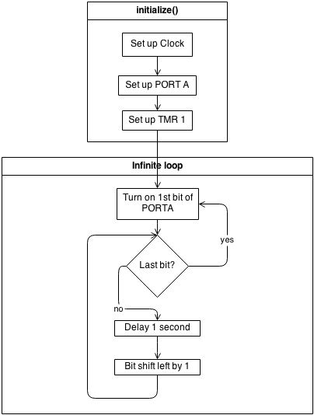

Figure 1: Flow diagram of design

* See the end of the report for the code of the design

# Verification

Verification was of the program was performed using the Explorer 16 board and an oscilloscope. The oscilloscope was used to measure the logic output and the timing of RA4. RA4 was first observe to see that it does indeed toggle on and off. Once this was verified to work as expected, the period of the signal was then measured. Since the program uses the lower 8 bits of PORT A, the period of RA4 should be 8 seconds. See the verification signature on the next page for proof that the program did indeed met the specification requirements.

# Conclusions and Limitations

It was concluded that the design meet all the specification requirements. No limitations were found.